*Highlighted part is either note to internal team or content that needs to be replaced with correct values e.g. email addresses, dates, etc.*

Below is a complete Data Retention Policy draft for SproutSong / SproutMentors, prepared for internal review, DPDP compliance tracking, and later website publication.

It defines how long each data category should be stored, what happens after the retention period, and how deletion/anonymisation should be technically implemented.

---

SproutSong / SproutMentors

Data Retention Policy

Internal Review Draft for Compliance Tracking

Document Name: Data Retention Policy
Platform: SproutSong / SproutMentors
Version: v1.0 Draft
Prepared For: Internal Review, DPDP Compliance Tracking, Website Publication
Status: Draft — Legal Review Pending
Effective Date: To be added
Last Updated: To be added
Privacy Contact: privacy@sproutsong.com
Support Contact: support@sproutsong.com

---

Internal Review Checklist

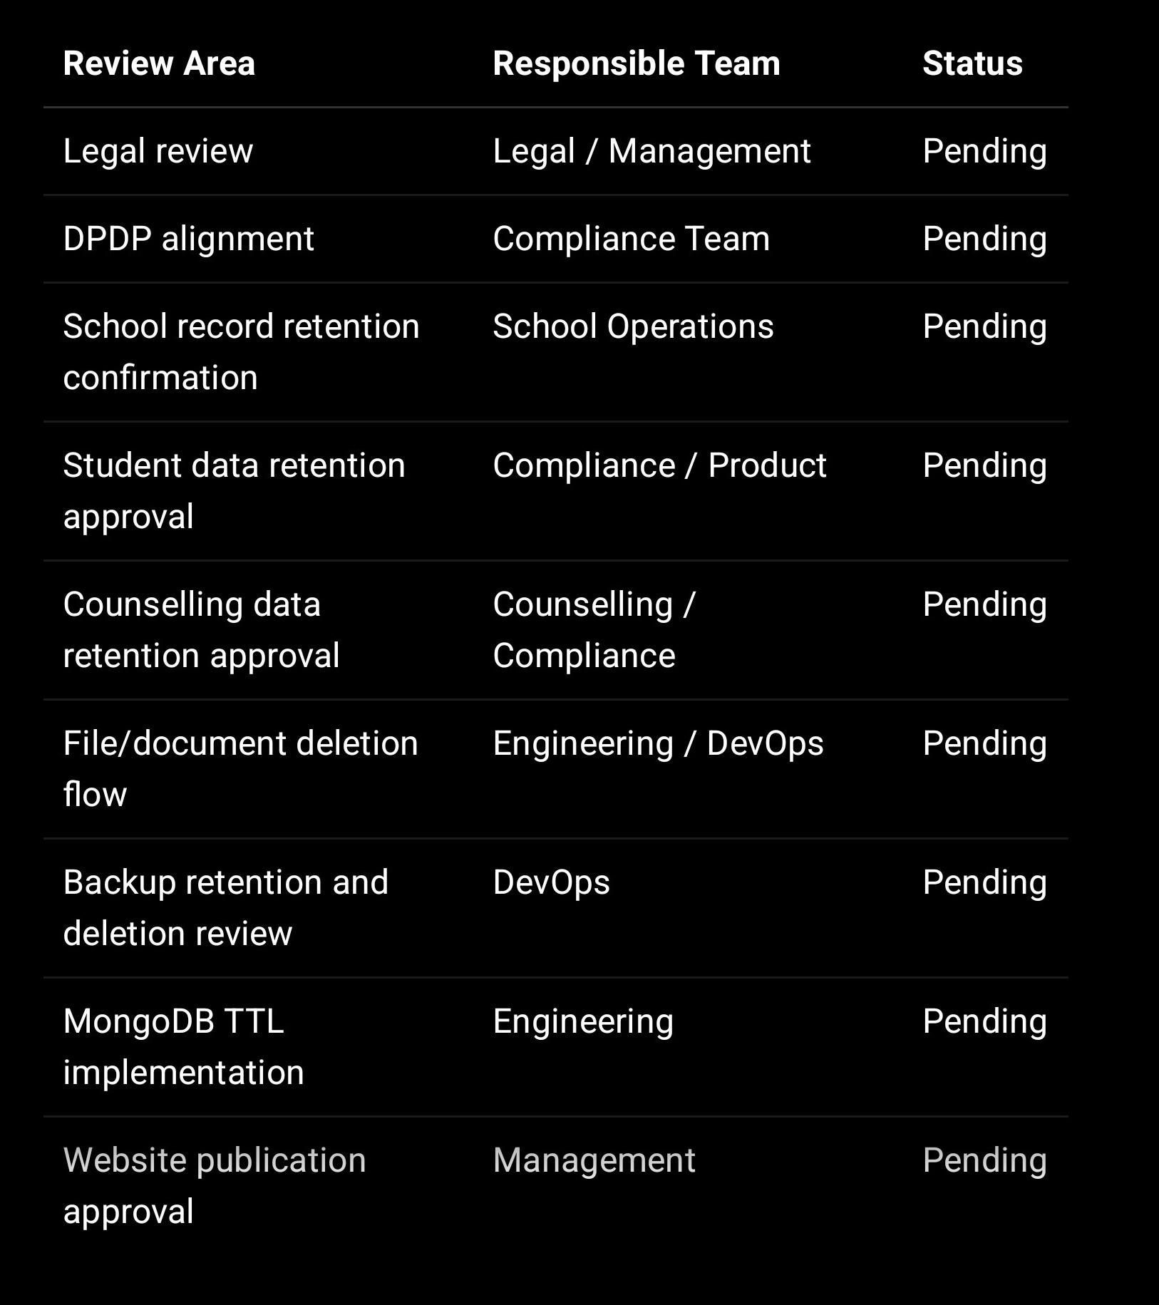

---

1. Purpose of This Policy

This Data Retention Policy defines how long SproutSong / SproutMentors stores different categories of data and how the data is deleted, anonymised, archived, or retained after the retention period ends.

The policy applies to student data, parent/guardian data, teacher data, school data, counselling data, AI reports, attendance, exams, assessments, documents, forms, logs, backups, consent records, and security records.

SproutSong’s internal DPDP/security report already identifies lack of visible consent and retention fields as a major risk, and recommends adding soft-delete and retention fields to collections.

---

2. Core Retention Principles

SproutSong / SproutMentors should follow these principles:

1. Keep data only as long as needed.

2. Delete or anonymise data after the purpose is complete.

3. Retain records required for legal, academic, audit, security, or school obligations.

4. Apply shorter retention for sensitive data such as counselling, financial context, medical details, AI prompts, and uploaded documents.

5. Use automatic deletion where possible through TTL jobs or scheduled cleanup scripts.

6. Delete linked files from storage buckets when database records are deleted.

7. Keep proof of consent and audit history where required for compliance.

8. Do not keep production student data in development/testing without masking.

Your teamship checklist also requires the team to ask whether a deletion/retention process exists during every review.

---

3. Scope of This Policy

This policy applies to data stored in:

MongoDB collections
File storage buckets
Application logs
Audit logs
Backups
Email/SMS systems
AI processing logs
Report/document storage
Analytics tools
Admin/support systems
Development/staging environments

It applies to:

Students
Parents/guardians
Teachers
Mentors
Counsellors
Educators
Schools/institutions
School admins/principals
Public visitors
Internal SproutSong users

---

4. Data Retention Summary Table

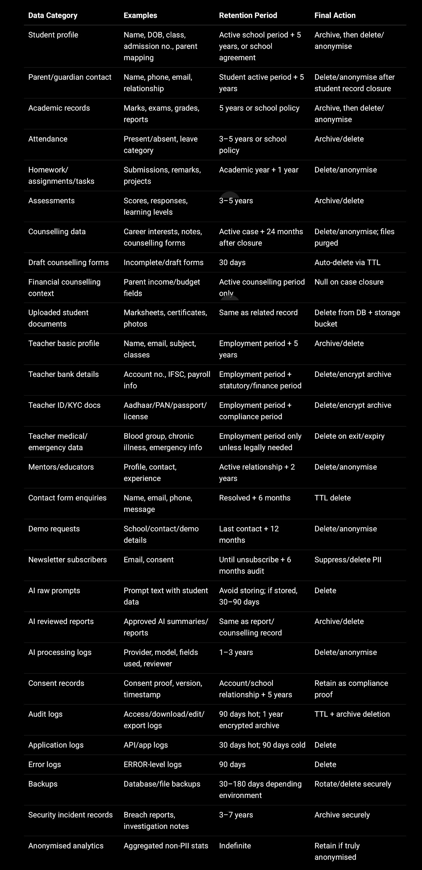

---

5. Detailed Retention Rules by Data Category

5.1 Student Profile Data

Includes:

Student name
DOB
Gender
Class/section
Roll number
Admission number
School ID
Parent linkage
Student status
Profile photo reference

Retention period:
Active school relationship + 5 years, unless school agreement requires a shorter or longer period.

Action after retention:
Archive first if needed for school records. Then delete or anonymise.

Technical rule:

retentionCategory: "STUDENT_PROFILE",
retentionUntil: calculateStudentRetention(studentLeavingDate, 5, "years")

Recommended deletion/anonymisation:

await Student.updateOne(
{ _id: studentId },
{
$set: {
fullName: "Deleted Student",
dob: null,
parentIds: [],
profilePhotoPath: null,
isAnonymised: true,
anonymisedAt: new Date()
}
}
);

---

5.2 Parent / Guardian Data

Includes:

Parent name
Phone
Email
Relationship
Consent details
Communication preferences

Retention period:
Student active period + 5 years.

Action after retention:
Delete or anonymise parent data unless linked to another active child.

Important:
If one parent is linked to multiple children, do not delete parent data until all linked student retention periods have expired.

---

5.3 Academic Records

Includes:

Marks
Grades
Exams
Assessments
Reports
Academic comments
Subject-wise performance

Retention period:
5 years or as per school/institution policy.

Action after retention:
Archive for school record if needed, then delete/anonymise.

Access during archive:
Read-only and restricted to school admin/principal only.

---

5.4 Attendance Data

Includes:

Attendance date
Present/absent/late/leave
Reason category
Restricted reason note
Marked by teacher
Edit history

Retention period:
3–5 years or as per school policy.

Action after retention:
Archive/delete.

Special rule:
Free-text absence reasons should not be stored long-term. Your internal report states that attendance reasons can become sensitive where they include illness, family problems, medical reasons, or personal circumstances, and recommends controlled categories with restricted reason notes.

Recommended:

reasonNote: {
type: String,
select: false,
retentionUntil: Date
}

If long-term attendance is retained, keep only:

studentId
date
status
reasonCategory

and delete restricted free-text notes earlier.

---

5.5 Homework, Assignments, Tasks, and Projects

Includes:

Homework records
Assignment submissions
Teacher remarks
Project files
Task completion status

Retention period:
Academic year + 1 year.

Action after retention:
Delete student submissions and associated files, or anonymise if used for aggregate analytics.

Technical action:
Remove file paths and delete physical files from storage bucket.

---

5.6 Exams and Assessments

Includes:

Exam schedule
Responses
Marks
Assessment scores
Teacher remarks
Result publication records

Retention period:
3–5 years or school policy.

Action after retention:
Archive final marks/results where needed, delete detailed responses and raw assessment records after the retention period.

Recommended split:

Data Retention

Final marks/report 5 years
Raw responses/drafts Academic year + 1 year
Internal scoring logs 1–2 years

---

5.7 Counselling and Career Guidance Data

Includes:

Counselling forms
Career interests
Academic documents
Counsellor notes
Parent/student inputs
Guidance reports
Financial context such as parent income/budget, if collected

Retention period:
Active counselling period + 24 months after case closure.

Your form security guide specifically recommends active counselling + 24 months after case closure, draft/incomplete records auto-delete after 30 days, uploaded documents retained for the same period as the record, financial fields nulled on case closure, and deletion within 72 hours of a valid erasure request.

Actions after closure:

1. Null financial data immediately on case closure.

2. Keep final counselling record for 24 months.

3. Delete DB record and associated files after retention.

4. Anonymise aggregate insights if needed.

Financial data nulling:

await CounsellingRequest.updateOne(
{ _id: counsellingId },
{
$set: {
fatherIncome: null,
motherIncome: null,
budget: null,
financialDataDeletedAt: new Date()
}
}
);

Draft deletion:

CounsellingRequestSchema.index(
{ draftExpiresAt: 1 },
{ expireAfterSeconds: 0 }
);

---

5.8 Uploaded Documents and Files

Includes:

Marksheets
Certificates
Profile photos
Counselling documents
Reports
Teacher documents
School documents

Retention period:
Same as the related record.

Deletion process:
Deleting only the MongoDB record is not enough. You must delete the linked files from the storage bucket as well. Your form guide explicitly states that erasure requires cascade delete of the MongoDB document and all associated files; orphaned files are incomplete erasure.

Required file deletion flow:

async function deleteRecordWithFiles(recordId) {
const record = await CounsellingRequest.findById(recordId);

const fileKeys = [
record.std8FilePath,
record.std9FilePath,
record.std10FilePath,
record.std11FilePath,
record.std12FilePath,
record.photoPath
].filter(Boolean);

for (const key of fileKeys) {
await storage.deleteObject(key);
}

await CounsellingRequest.deleteOne({ _id: recordId });
}

Policy rule:
All file records must store storage keys, not public URLs.

---

5.9 Teacher Profile Data

Teacher data should be split into separate retention groups because the uploaded teacher profile data includes bank, ID, medical, family, and professional information. Your DPDP/security report recommends splitting teacher profile into separate collections and encrypting bank, PAN, Aadhaar, passport, driving licence, medical details, address, family phone, and signature.

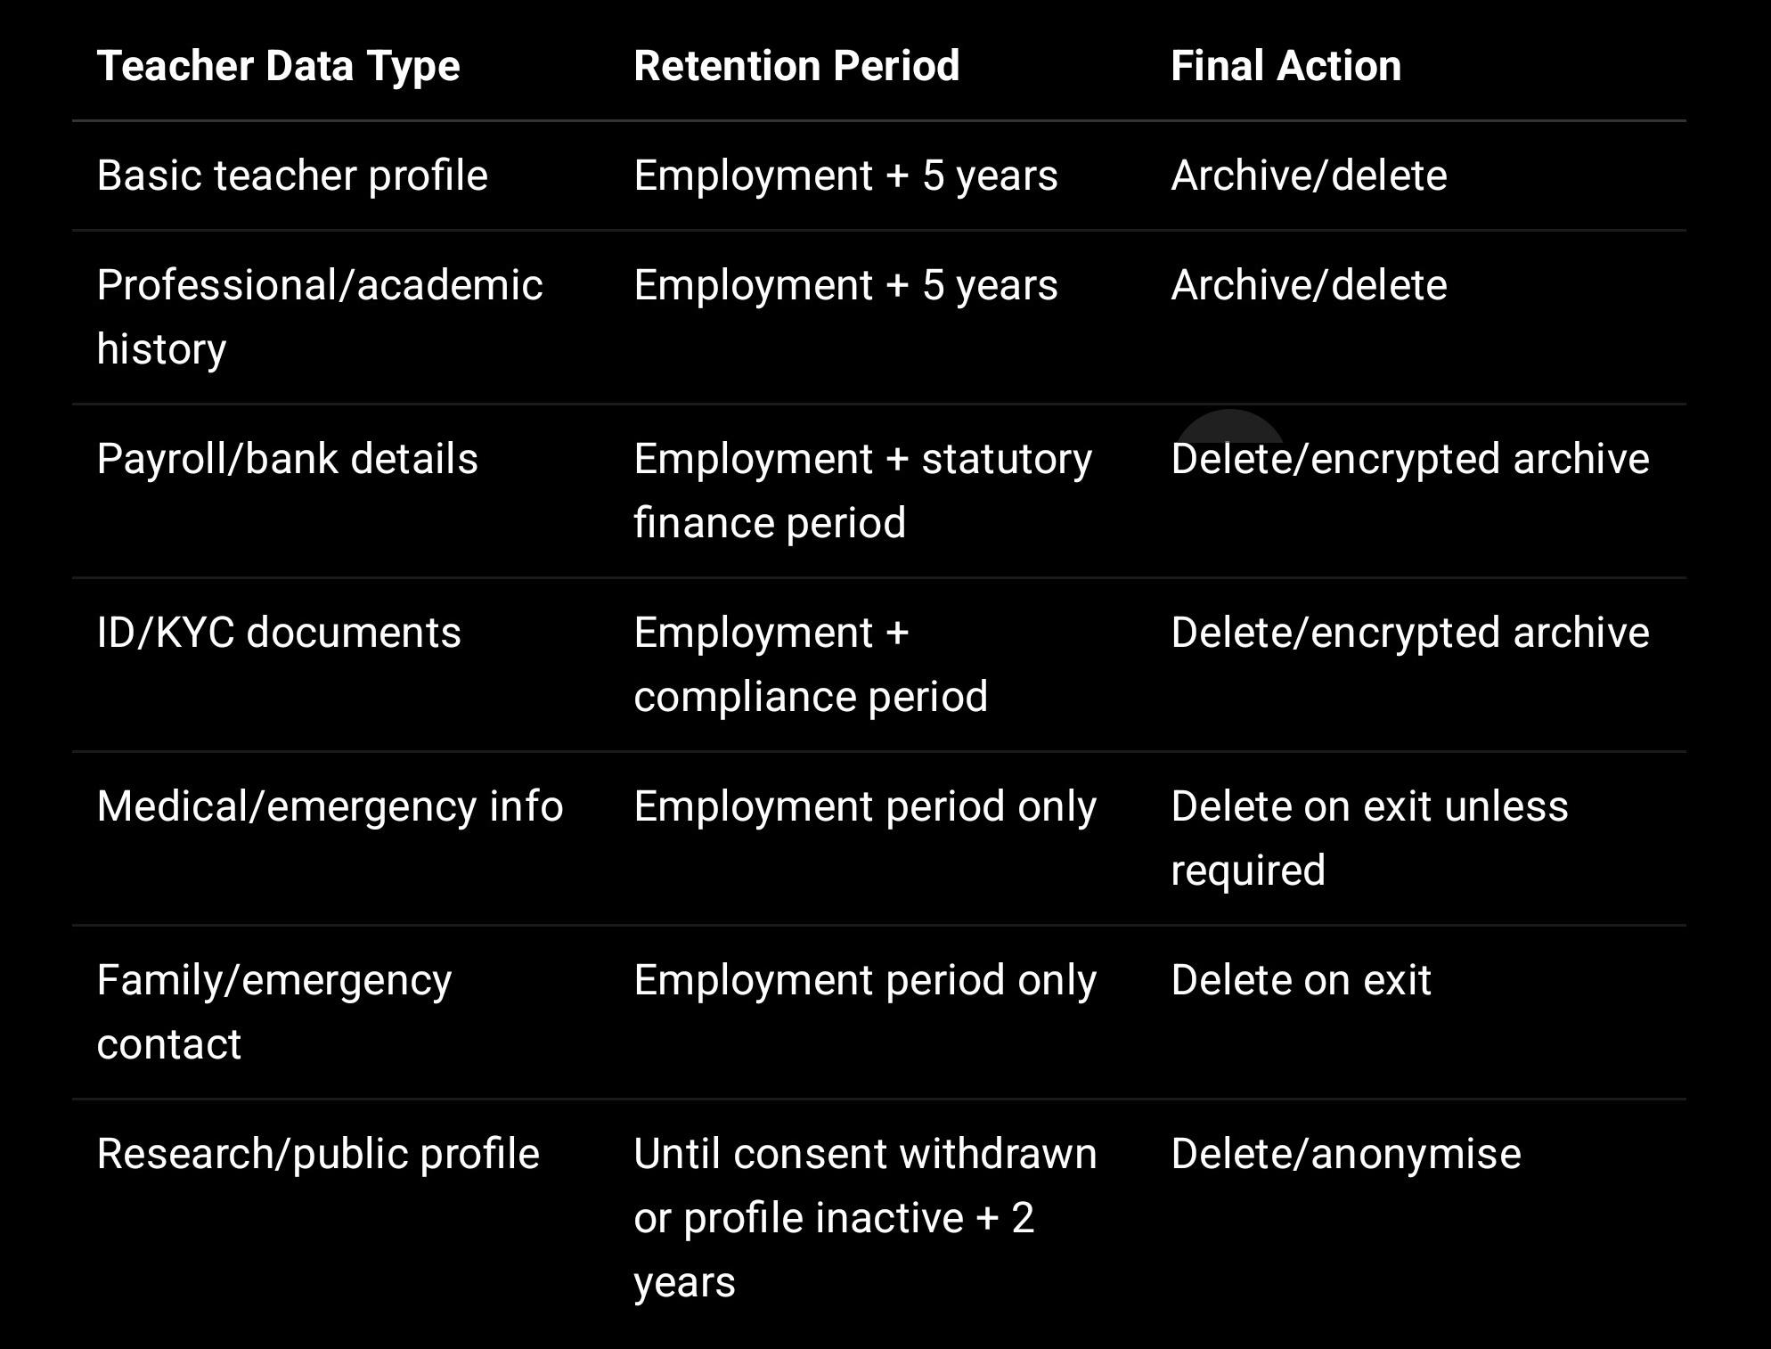

---

5.10 Mentors, Counsellors, and Educators

Includes:

Name
Email
Mobile
Profile
Qualification
Experience
Availability
Professional information

Retention period:
Active relationship + 2 years.

Action after retention:
Delete/anonymise profile data unless required for contracts, payments, audit, or legal claims.

---

5.11 Public Contact Forms

Includes:

Name
Email
Phone
Message
Status
Submitted time

Retention period:
Resolved/closed + 6 months. Pending/open records: keep until resolved + 30 days.

Your form security guide says contact form records should be kept only until resolution + 30 days for open cases, and resolved/closed records should auto-delete 6 months after resolution using MongoDB TTL; anonymised aggregate data may be retained.

TTL example:

ContactRequestSchema.index(
{ deleteAfter: 1 },
{ expireAfterSeconds: 0 }
);

On closure:

contact.status = "CLOSED";
contact.resolvedAt = new Date();
contact.deleteAfter = addMonths(new Date(), 6);
await contact.save();

---

5.12 Demo Requests

Includes:

School name
Contact person
Email
Phone
School type
Board
Demo preference
Notes

Retention period:
12 months after last contact or last follow-up.

Action after retention:
Delete/anonymise. Keep aggregate non-PII pipeline metrics if needed.

---

5.13 Newsletter / Marketing Consent

Includes:

Email
Name, if provided
Consent status
Opt-in timestamp
Unsubscribe timestamp

Retention period:
Until unsubscribe + 6 months audit period.

Action after retention:
Remove PII from active list. Keep hashed email in suppression list if required to avoid accidental re-subscription.

{
emailHash: hmac(email),
unsubscribedAt,
suppressionReason: "USER_UNSUBSCRIBED"
}

---

5.14 AI Data

Includes:

AI prompts
AI draft outputs
Reviewed AI reports
AI processing logs
Model metadata
Reviewer data
Consent reference

Retention periods:

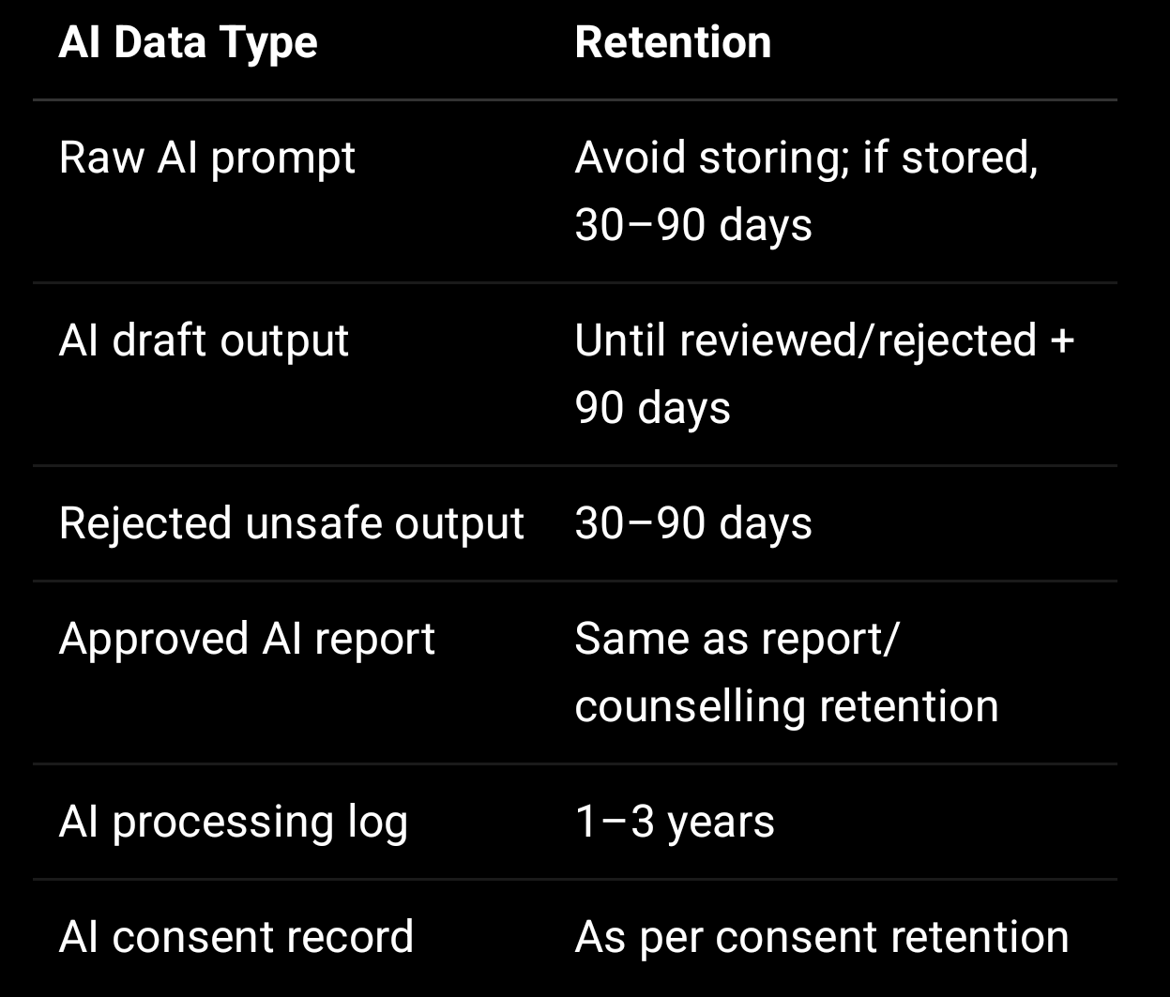

Your internal report recommends not storing full AI prompts with unnecessary personal data unless required, logging AI usage, requiring human review, and allowing correction of AI-generated reports.

Deletion rule:
When deleting AI records, remove raw prompts first, then drafts, then approved output according to linked report retention.

---

5.15 Consent Records

Includes:

Consent type
Consent text/version
Policy versions
Timestamp
Checkbox proof
IP/user agent
Parent/guardian details
Withdrawal status

Retention period:
Account/school relationship + 5 years, or as required for compliance proof.

Action after retention:
Keep minimal proof where required, anonymise direct PII where possible.

Suggested:

{
consentType,
agreedAt,
consentVersion,
privacyPolicyVersion,
dataPrincipalIdHash,
withdrawn,
withdrawnAt
}

---

5.16 Audit Logs and Security Logs

Your secure logging guide gives specific retention periods: application logs 30 days hot / 90 days cold, HTTP access logs 30 days, security/audit logs in MongoDB with TTL 90 days, error logs 90 days, and encrypted backup of audit logs for 1 year.

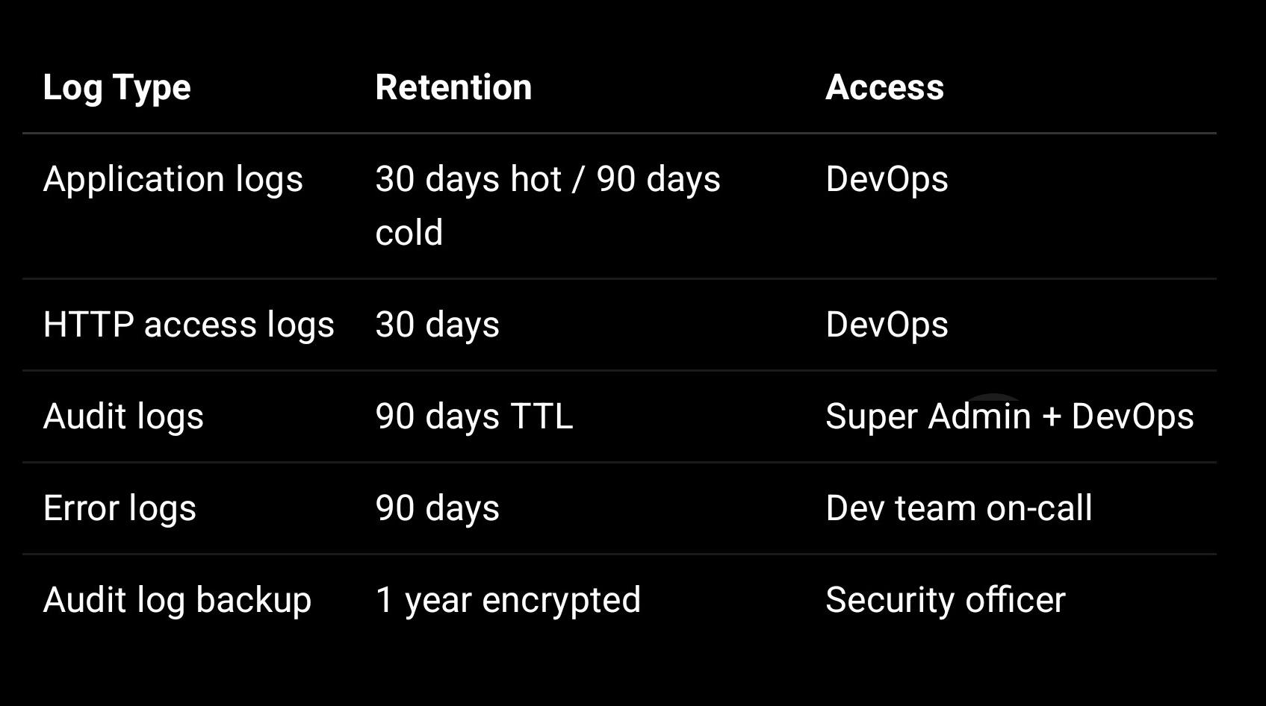

Important:
Logs must not store PII such as passwords, tokens, OTPs, full email, full phone, student names, parent names, DOB, counselling notes, bank details, stack traces in production, or MongoDB query objects.

---

5.17 Backups

Includes:

MongoDB backups
File storage backups
Audit log backups
Encrypted archive backups

Retention period:

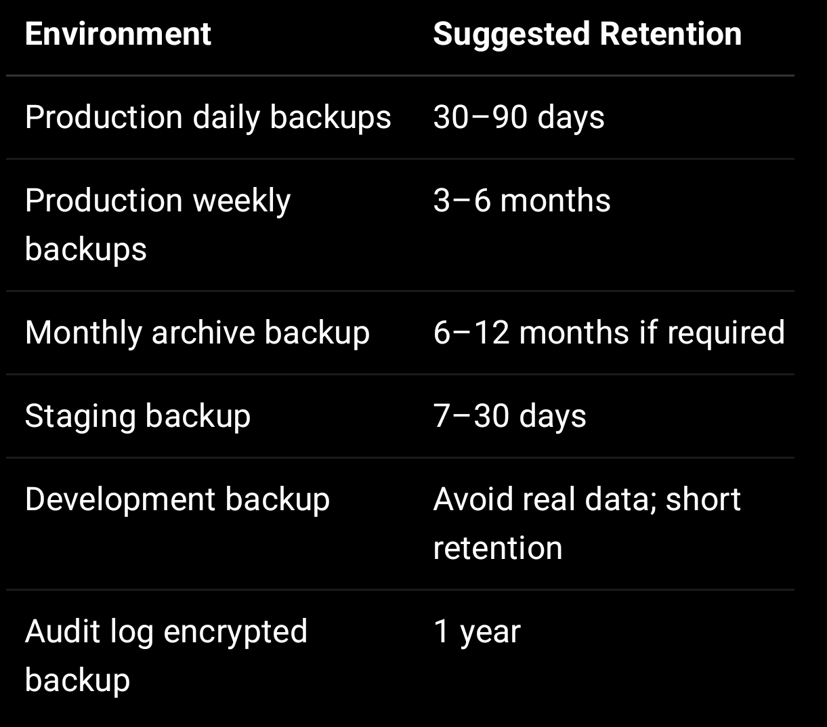

Your MongoDB security guide recommends encrypted backups, backup rotation, monthly restore testing, and not using production backups in development without masking.

Backup deletion:
Backups must be rotated automatically and deleted securely after expiry.

---

5.18 Security Incident Records

Includes:

Incident report
Breach analysis
Affected records count
Actions taken
Notifications
Evidence logs
Root cause analysis

Retention period:
3–7 years depending on legal/compliance requirements.

Action after retention:
Archive securely or delete after legal review.

---

6. Required Schema Fields for Retention

Add these fields to all personal-data collections:

{
retentionCategory: String,
retentionUntil: Date,
isArchived: {
type: Boolean,
default: false
},
archivedAt: Date,
isDeleted: {
type: Boolean,
default: false
},
deletedAt: Date,
deletedBy: ObjectId,
deletionReason: String,
anonymisedAt: Date,
deleteAfter: Date
}

Your DPDP report already recommends adding common fields such as deletedAt, deletedBy, isDeleted, retentionCategory, and consent/policy fields to major collections.

---

7. Retention Status Lifecycle

Use the following lifecycle:

ACTIVE
ARCHIVED
PENDING_DELETION
DELETED
ANONYMISED
LEGAL_HOLD

Meaning

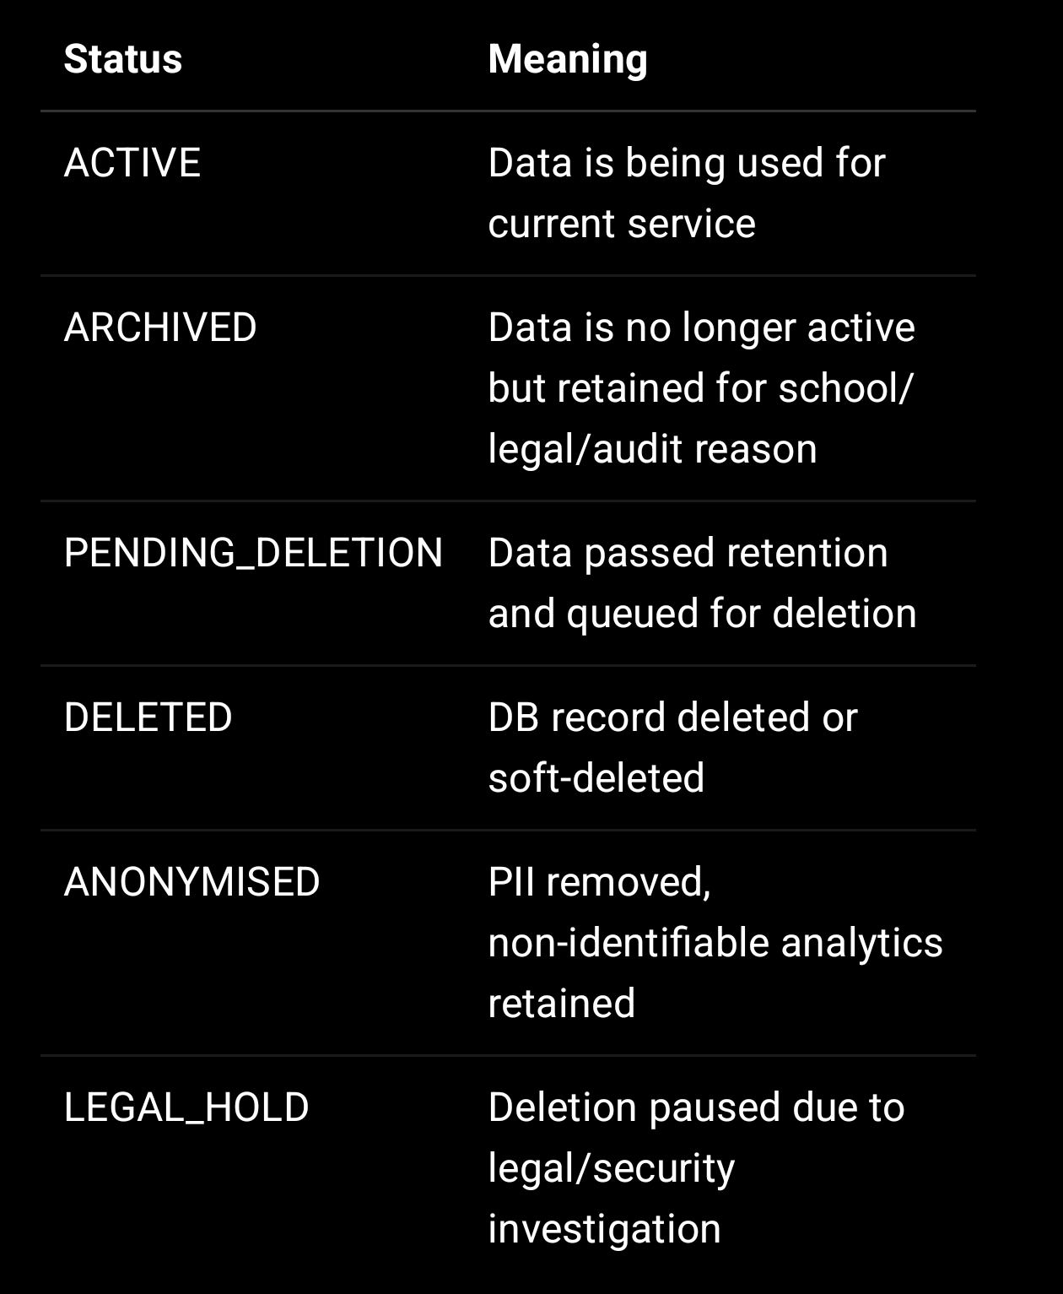

---

8. Deletion Process

Step 1: Identify Expired Records

Run daily scheduled job:

const expiredRecords = await Student.find({
retentionUntil: { $lte: new Date() },
retentionStatus: { $nin: ["DELETED", "LEGAL_HOLD"] }
});

Step 2: Check Legal / School Hold

Do not delete if:

School has active agreement requiring retention
Legal case is active
Security incident investigation is active
Payment/audit dispute is active
Academic record retention is still required

if (record.legalHold === true) {
continue;
}

Step 3: Delete or Anonymise

Use category-specific deletion rules:

Student profile: anonymise or delete
Counselling: delete DB + files
Contact form: delete
Logs: TTL delete
Documents: delete storage object + DB metadata
AI prompt: delete
AI report: follow linked report retention

Step 4: Delete Linked Files

For every document/file path, delete from bucket.

await storage.deleteObject(fileKey);

Step 5: Write Deletion Audit Log

await AuditLog.create({
module: "retention",
action: "DATA_DELETED",
result: "allowed",
recordType: "CounsellingRequest",
recordId,
schoolId,
createdAt: new Date()
});

Step 6: Record Deletion Certificate

Create a deletion_records entry:

{
recordType,
recordId,
schoolId,
deletedAt,
deletionMethod: "HARD_DELETE | SOFT_DELETE | ANONYMISE | FILE_PURGE",
deletedFileKeys,
reason: "RETENTION_EXPIRED",
performedBy: "SYSTEM_JOB",
requestId
}

---

9. Deletion Request Process

A parent, school, teacher, mentor, visitor, or user may request deletion by contacting:

privacy@sproutsong.com

Process

- Request received.
- Identity/authority verified.
- Related records identified.
- Check whether data can be deleted or must be retained.
- Delete/anonymise eligible records.
- Delete linked files.
- Mark consent withdrawn if applicable.
- Send completion response.
- Store deletion record.

Your form guide says parent/guardian can request full deletion of counselling data, and valid erasure requests should delete both the DB record and files, with processing within 72 hours for the counselling form context.

—

10. MongoDB TTL Implementation

TTL indexes are recommended for short-lived data such as drafts, contact requests, OTPs, password reset tokens, temporary uploads, and logs.

Example: Draft counselling form

CounsellingRequestSchema.index(
{ draftExpiresAt: 1 },
{ expireAfterSeconds: 0 }
);

Example: Contact request delete after closure

ContactRequestSchema.index(
{ deleteAfter: 1 },
{ expireAfterSeconds: 0 }
);

Example: Audit logs

Your MongoDB security guide includes a verification item for TTL index on audit_logs with expireAfterSeconds: 7776000, which equals 90 days.

AuditLogSchema.index(
{ createdAt: 1 },
{ expireAfterSeconds: 7776000 }
);

Example: OTP records

OtpSchema.index(
{ expiresAt: 1 },
{ expireAfterSeconds: 0 }
);

—

11. Data Anonymisation Rules

If data is retained for analytics after the retention period, it must be anonymised.

Remove:

Name
Email
Phone
DOB
Address
Admission number
Parent details
File paths
Free-text notes
Counselling comments
Photos/documents
Raw AI prompts
Retain only:
Class/grade level
Subject category
Aggregated marks bands
Non-identifiable trend
Count-based metrics
School-level aggregate where contract permits

Example:

{
classLevel: "Grade 10",
subject: "Science",
performanceBand: "70-80",
year: "2026",
count: 42
}

—

12. Data Masking for Development

Production student/teacher data should not be used in development or staging unless masked.

Your MongoDB security guide and DPDP report recommend not using production backup in development without masking.

Example masking:

db.students.find().forEach(doc => {
db.students.updateOne(
{ _id: doc._id },
{
$set: {
fullName: "Student " + doc._id.toString().slice(-4),
dob: null,
"parents.fatherMobile": "9999999999",
"parents.fatherEmail": "masked@example.com",
"parents.motherMobile": "9999999998",
"parents.motherEmail": "masked@example.com"
}
}
);
});

—

13. Retention Policy for Backups

Because backups may contain deleted data until rotation completes, the policy should clearly state this.

Backup rules

- Backups must be encrypted.
- Backups must have automatic expiry.
- Backup access must be restricted.
- Restore tests must be done monthly.
- Deleted data may remain in encrypted backups until backup expiry.
- Backups must not be restored into development without masking.

Suggested website wording:

Deleted data may remain temporarily in encrypted backups until the backup retention period expires. During this period, backup access is restricted and the data is not used for active processing.

—

14. Internal Roles and Responsibilities

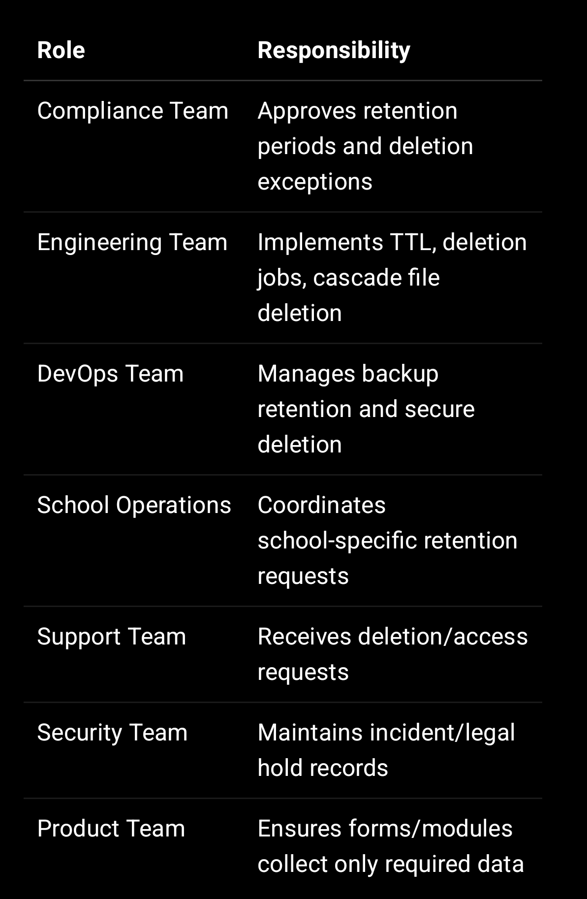

—

15. Compliance Tracking Collection

Create a retention_policies collection:

const RetentionPolicySchema = new mongoose.Schema({
dataCategory: {
type: String,
required: true,
unique: true
},

description: String,

retentionPeriodValue: Number,

retentionPeriodUnit: {
type: String,
enum: ["DAYS", "MONTHS", "YEARS"]
},

triggerEvent: {
type: String,
enum: [
"CREATED_AT",
"CASE_CLOSED",
"ACADEMIC_YEAR_END",
"STUDENT_LEFT",
"EMPLOYMENT_ENDED",
"RESOLVED_AT",
"CONSENT_WITHDRAWN",
"LAST_CONTACT"
]
},

actionAfterExpiry: {
type: String,
enum: [
"DELETE",
"ANONYMISE",
"ARCHIVE",
"NULL_SENSITIVE_FIELDS",
"DELETE_FILES_AND_RECORD",
"LEGAL_REVIEW"
]
},

legalHoldAllowed: {
type: Boolean,
default: true
},

active: {
type: Boolean,
default: true
},

approvedBy: mongoose.Schema.Types.ObjectId,
approvedAt: Date
}, {
timestamps: true
});

—

16. Scheduled Retention Job Example

const cron = require("node-cron");

cron.schedule("0 2 * * *", async () => {
await processExpiredRecords();
});

async function processExpiredRecords() {
const now = new Date();

const records = await RetentionQueue.find({
processAfter: { $lte: now },
status: "PENDING"
}).limit(500);

for (const item of records) {
try {
if (item.legalHold) {
item.status = "LEGAL_HOLD";
await item.save();
continue;
}

if (item.action === "DELETE_FILES_AND_RECORD") {
await deleteFilesAndRecord(item);
}

if (item.action === "ANONYMISE") {
await anonymiseRecord(item);
}

if (item.action === "NULL_SENSITIVE_FIELDS") {
await nullSensitiveFields(item);
}

item.status = "COMPLETED";
item.completedAt = new Date();
await item.save();
} catch (error) {
item.status = "FAILED";
item.errorMessage = error.message;
await item.save();
}
}
}

—

17. User-Facing Website Summary

Use this shorter summary on the published website page:

SproutSong / SproutMentors keeps personal data only for as long as required for educational, academic, counselling, reporting, communication, security, legal, audit, or school administration purposes.

Student and academic records are retained according to school and academic requirements. Counselling records are retained for the active counselling period and a limited period after closure. Public contact requests are deleted after resolution. Uploaded documents are deleted when the related record expires or when a valid deletion request is completed.

Where data is no longer required, it is deleted, anonymised, archived, or securely removed from active systems. Some data may remain temporarily in encrypted backups until the backup retention period expires.

Parents, guardians, schools, teachers, and users may request deletion or correction by contacting privacy@sproutsong.com.

—

18. Final Publishing Checklist

Before publishing this policy:

- Confirm final legal entity name.
- Confirm school-specific academic retention needs.
- Confirm final backup retention period.
- Confirm counselling retention period.
- Confirm audit log retention period.
- Confirm file storage deletion mechanism.
- Add retentionUntil to key schemas.
- Add TTL indexes for draft/contact/log/OTP data.
- Add cascade file deletion job.
- Add deletion request workflow.
- Add legal hold mechanism.
- Add anonymisation workflow.
- Add backup rotation verification.
- Add policy version to compliance records.
- Link this policy with Privacy Policy, Consent Policy, Child Data Protection Policy, DPA, and Terms.

—

Final Internal Note

This Data Retention Policy should be published together with:

Terms & Conditions
Privacy Policy
Child Data Protection Policy
Consent Policy
School Data Processing Agreement
Breach Response Policy
AI Usage Disclaimer
Cookie Policy, if analytics/cookies are used

Your internal guide explicitly lists Data Retention Policy as one of the recommended public/compliance documents for DPDP readiness.

